**INTERVIEW SCHEDULER USING Django**

**Git**

**https://github.com/Gopikavgk/**

Packages Used (please try to use these packages, to prevent unexpected errors)

1. **djangorestframework==3.12.3**
2. **django==** **3.2.12**
3. **Python 3.7.9**

***Django***

App name where user can schedule interview is shoppig_app

1).Django project consists of an application named 'shoppig_app'. On going to <http://127.0.0.1:8000/>

We see following URL paths:



Similarly , <http://127.0.0.1:8000/shoppig_app/>

Will have following API path for these API GET Calls:

* 1)Adding candidate_slot

http://127.0.0.1:8000/shoppig_app/candidate_slot?candidate_ID=ID&candidate_name=NAME&start_time=XX&end_time=XX

Fill parameters as required

* 2) Adding interviewer_slot

<http://127.0.0.1:8000/shoppig_app/interviewer_slot?interviewer_ID=ID&interviewer_name=NAME&start_time=XX&end_time=XX>

Fill parameters as required

* 3) Calculate_slot

Fill parameters as required

<http://127.0.0.1:8000/shoppig_app/calculate_slot?interviewer_id=ID&candidate_id=ID>

All API calls and the examples with screenshot are attached below

***1 ) API to insert time slots for candidate***

Timings are expected to be in hours and in 24 Hour Format.

In production ,it can be modified using Front or Backend.

http://127.0.0.1:8000/shoppig_app/candidate_slot?candidate_ID=CNN01&candidate_name=Ravikumar&start_time=09&end_time=16

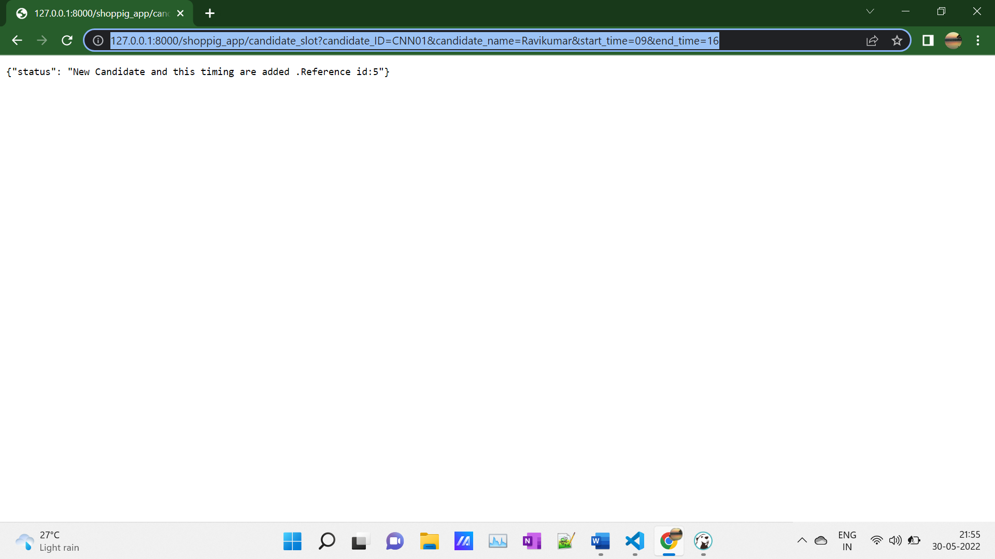

From here, details of a particular candidate can be added.

That is ,

* candidate_ID
* start_time
* end_time
* candidate_name

PFB Database

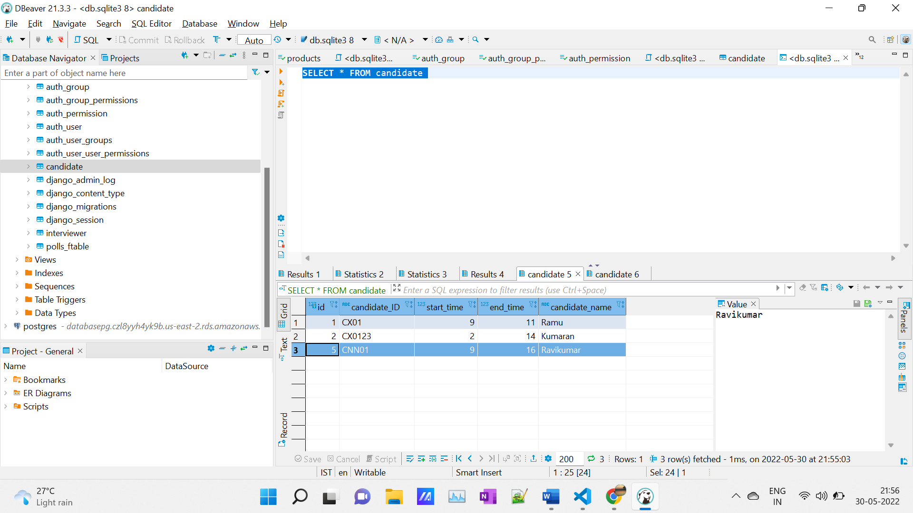

***2 ) API to insert time slots for interviewer***

<http://127.0.0.1:8000/shoppig_app/interviewer_slot?interviewer_ID=INOX345&interviewer_name=Johnson&start_time=12&end_time=15>

Timings are expected to be in 24 Hrs Format.

From here , details of a particular interviewer can be added.

That is,

* interviewer_ID
* start_time
* end_time
* interviewer_name

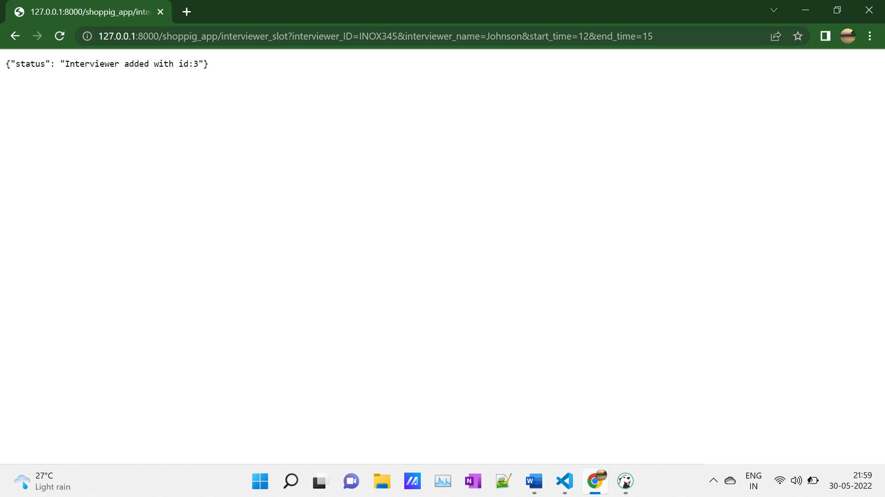

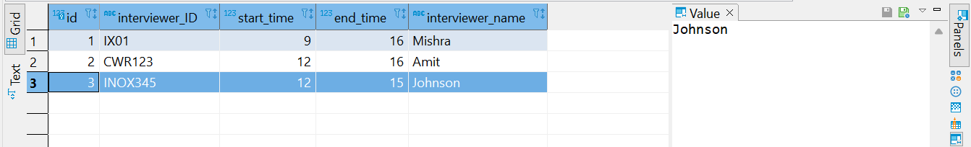

***3)API to Calculate Slots***

<http://127.0.0.1:8000/shoppig_app/calculate_slot?interviewer_id=INOX345&candidate_id=CX01>

No Common Slots are available for these interviewer and candidate

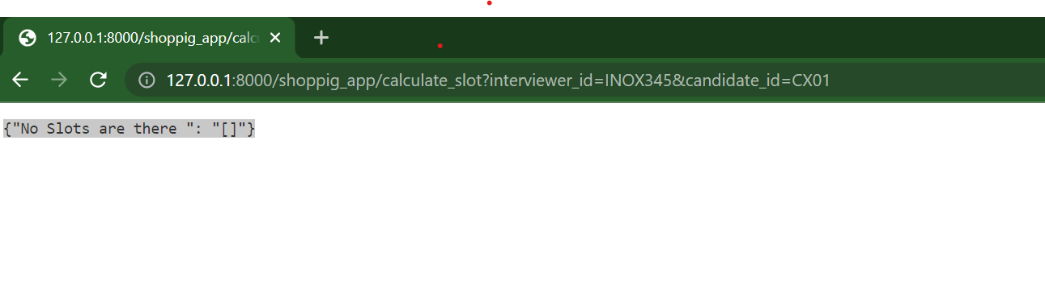

Slots are available for these

http://127.0.0.1:8000/shoppig_app/calculate_slot?interviewer_id=INOX345&candidate_id=CX0123

Interviewers In and Out Time 12 15

Canidates In and Out Time 2 14

Time between 12 and 14 is common for them and by applying 1 hr gap, our api can calculate values

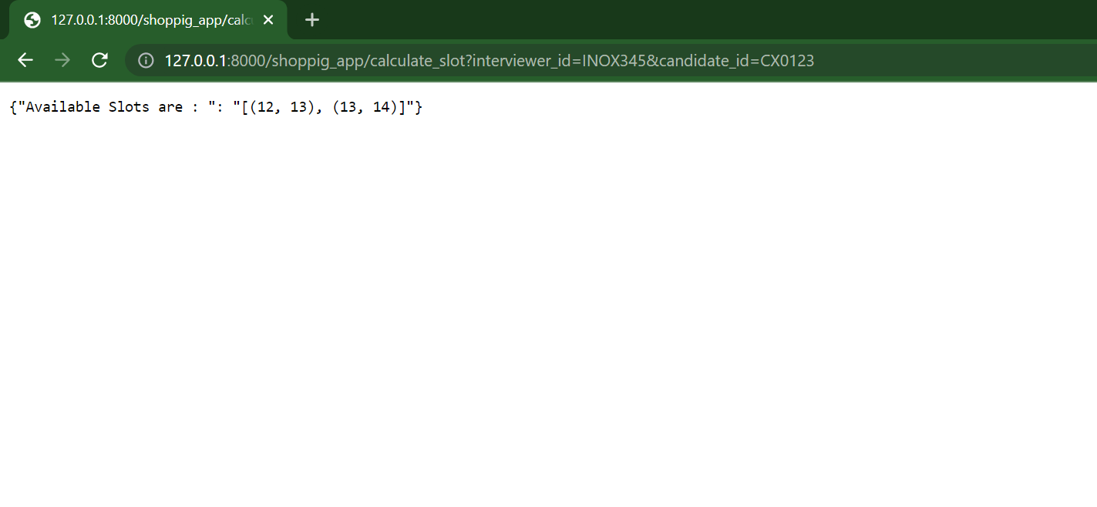

On passing the interviewer id and candidate id to the calculate_slot, the desired timeslots will be returned.

**Assumption**

1. **From the question of assignment, I assumed start-time and end-time should be made in hour-wise manner. Many Interview scheduling online tools also use that approach.**

**In case, If start-time and endtime should have flexibility of time like 9:52 to 10:52.Approach for that be implemented using time and seconds easily.**

1. **“24 Hour” format is used in this assignment for ease-ness. In Many realtime systems like Railways use this type of approach for clarity**

**In case , for user friendliness,if other convention need to be followed, it can be done and converted into the needed time system using backend and suitably frontend**